Do wish list entries for solved? and next-boards

solved?

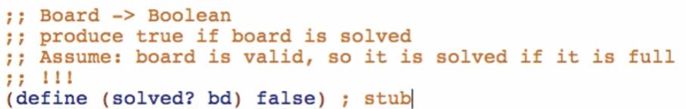

next-boards

